Favourite Product

Method 1:

Favourite Product:

A favourite product is a business model that allows our customer to add their favourite products in favourite list

> To enter the Favourite products user, need to login first.

After login they can be able to see Dashboard page.

URL for Dashboard page : <https://www.agilent.com/qa1/dashboard>

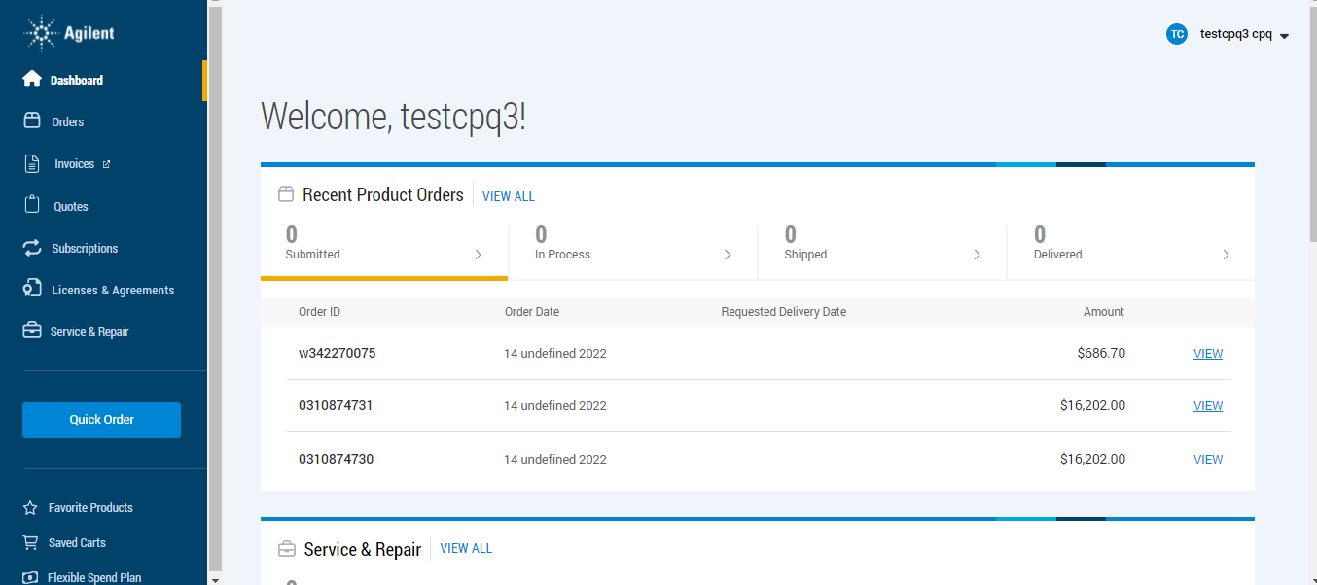

This is the dashboard view of our site. To add our favourite products select

“Favourite Products” button

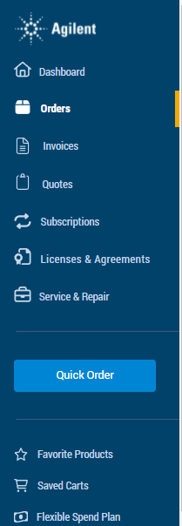

After selecting Favourite Products button, it will redirect into Favourite Product page

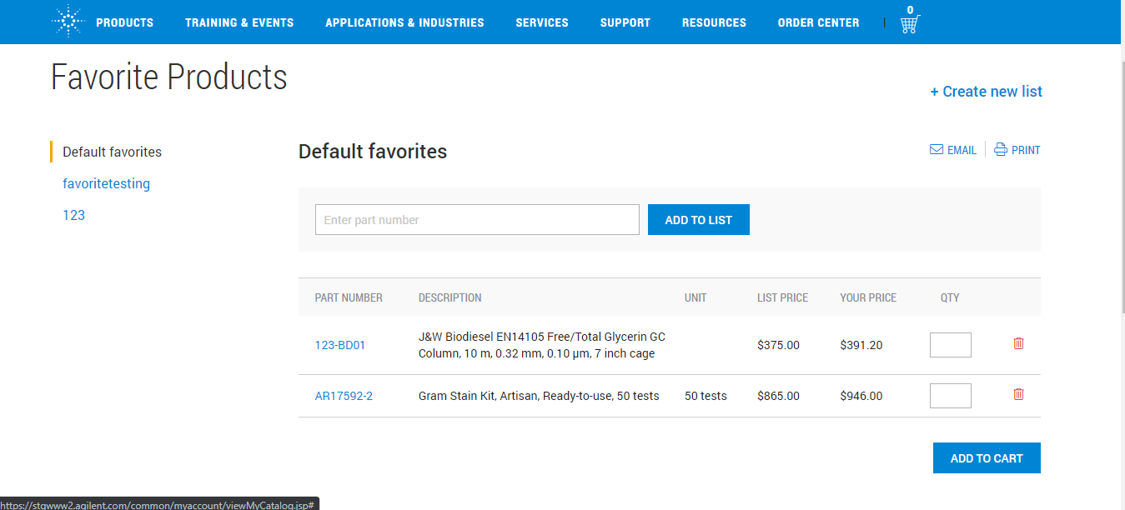

Here “Default favourites” is option is the default one.

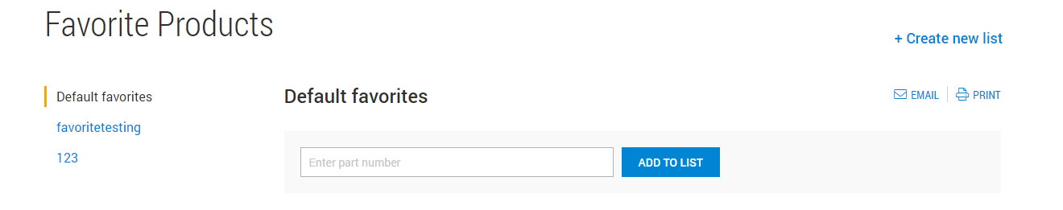

In Search Bar we can be able to add the product by selecting a “ADD TO LIST” button

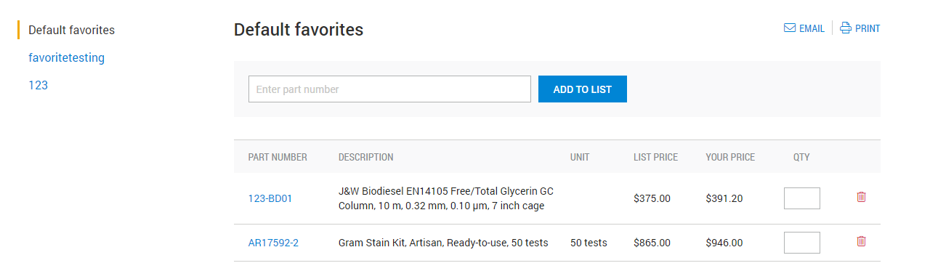

Here two products are added in “Default favourites”

Method 2

We can be able to add our favourite product in order centre. After selecting the product click “Add to Favourites “button.

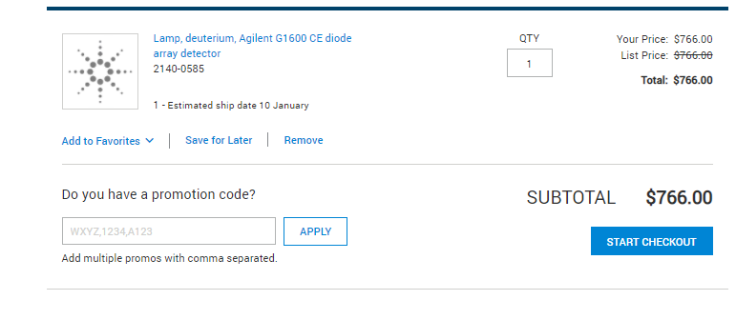

After clicking the “Add to Favourites “ button it will show list of existing list

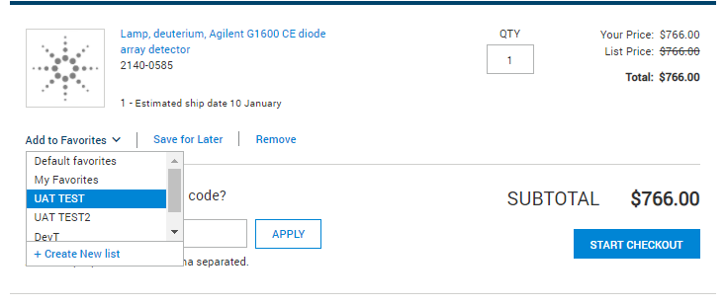

Here ,we can able to select the list



Here we selected the “UAT TEST” list

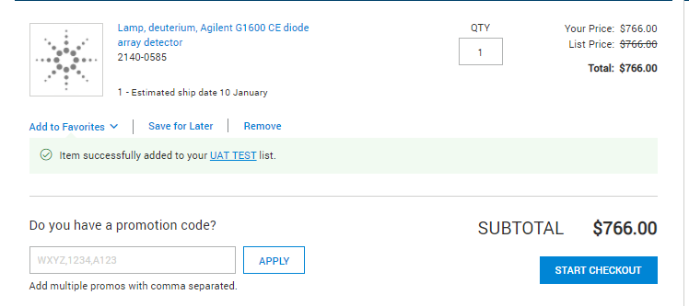

Now our item added in “UAT TEST“ list

Create new list

User can create their own list by clicking “+ Create new list“ button

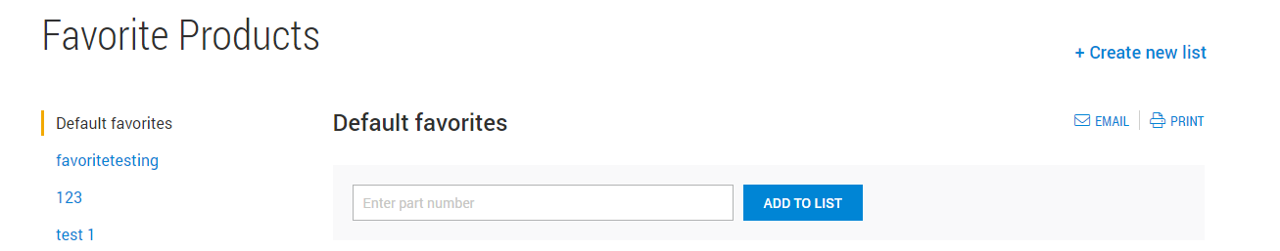

After selecting “ Create new list “ button

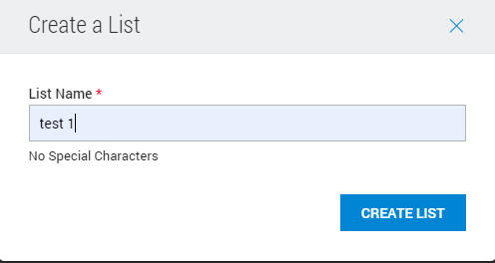

In List Name, type the name and click “CREATE LIST “ button

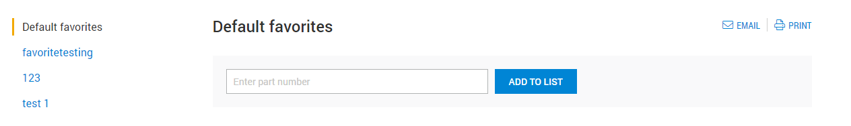

Now our “test 1 “Favourites listed is added

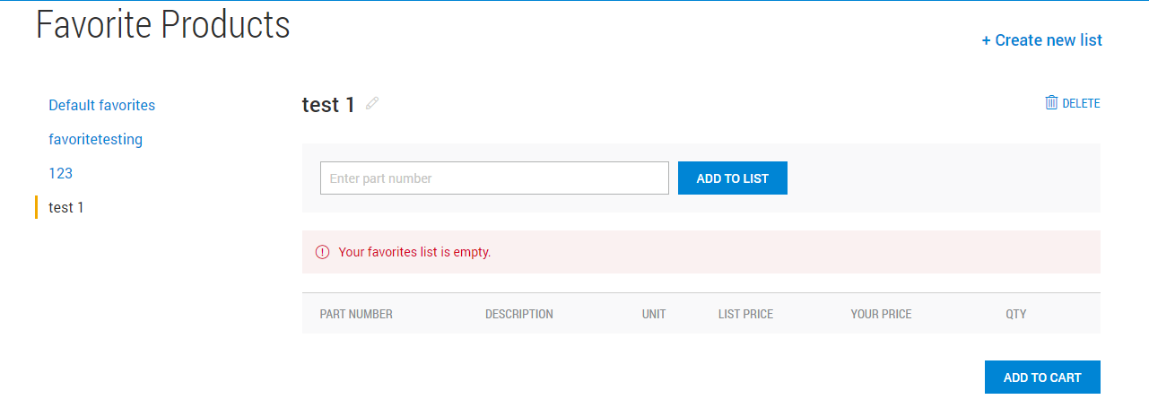

Now we can add product and select qty and click “ADD TO CART BUTTON”

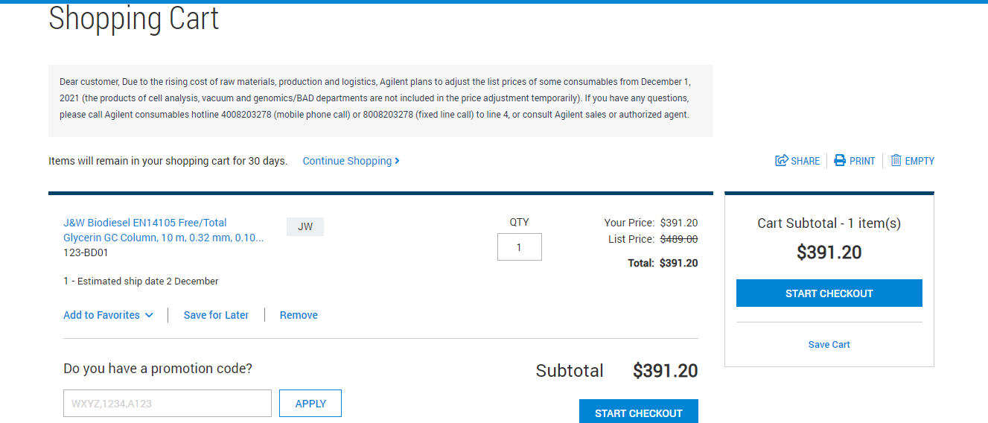

Our product is added to card and then we can able to check out by clicking “START CHECKOUT” BUTTON”